Machine learning process
Supervised machine learning algorithms use training examples to “learn” how to complete a task (Mohri, Rostamizadeh, & Talwalkar, 2012; Goodfellow, Bengio, & Courville, 2016). For example in our setting, we provided a set of animal images from camera traps of different species and their labels (species identifiers) to a deep neural network, and trained the model to identify species in training images. Once a model is trained, it learns how to classify new images that were not used for training.
One popular class of machine learning algorithms is artificial neural network, which loosely mimics how a network of neurons in a mammalian brain may respond to stimuli (Gurney, 2014; Goodfellow et al., 2016). An artificial neuron in a neural network has several inputs, each with an associated weight. For each artificial neuron, the inputs are multiplied by the weights, summed, and then evaluated by a non-linear function, which is called the activation function (e.g., Sigmoid, Tanh, ReLU, or Sine). Usually each neuron also has an extra connection with a constant input value of 1 and its associated weight, called “bias,” for neurons. The result of the activation function can be passed as an input to other artificial neurons or serve as network outputs. For example, consider an artificial neuron with three inputs ($I_{1}$, $I_{2}$, and $I_{3}$) and ReLu activation function; the output (θ) is calculated based on:
$θ= ReLu(w_{1}I_{1}+ w_{2}I_{2}+w_{3}I_{3}+b)$ (eqn 1),
where $w_{1}$, $w_{2}$, and $w_{3}$ are the weights associated with each input, and $b$ is the bias (Fig. 1). To solve complex problems multiple neurons are needed, so we put them into a network. We arrange neurons in a hierarchical structure of layers; neurons in each layer take input from the previous layer, process them, and pass the output to the next layer. In our species classification setting, the inputs to the network are normalized Red, Green, Blue (RGB) values of raw pixels of image and we interpret the output of the final layer as the probability of the presence of species in the image. A softmax function is used at the final layer to ensure that the outputs sum to one (Goodfellow et al., 2016).
To train a network, an algorithm called backpropagation (Rumelhart, Hinton, & Williams, 1986), tunes the parameters (weights and bias values) of the neural network, enabling it to produce the desired output when we feed an input to the network. To adjust the parameters, we define a loss function as a measure of the difference between the predicted (current) output of the neural network and the ground truth labels ($Y$). Different loss measures ($L)$ can be used but usually cross-entropy loss is employed for classification problems:
$L\left(P,Y\right)=-\sum_{i}{P_{i}log⁡(Y_{i})}$ (eqn2).
Where P is the output of the network and Y is the ground truth label in one-hot (binary) encoding format (i.e., 1 for the valid species and 0 for the others). The backpropagation algorithm computes the contribution (i.e., gradient) of each weight (bias is also a weight) to the loss value ($\frac{dL}{dW}$) using the chain rule in calculus. Weights are then adjusted so the loss value is minimized. Different formulas can be employed for this “weight update” step such as vanilla update rule shown in eqn 3:
$w_{i}=w_{i initial}- η\frac{dL}{dW}$ (eqn 3),
where $η$ is the learning rate and is chosen by the scientist. A higher $η$ indicates larger steps are taken per training sample, which may be faster, but a value that is too large will be imprecise and can destabilize learning. After adjusting the weights, the same input should result in an output that is closer to the desired output. For more details of backpropagation and training, see Goodfellow et al., 2016.
In fully connected neural networks, each neuron in every layer is connected to (provides input to) every neuron in the next layer. Conversely, in convolutional neural networks, which are inspired by the retina of the human eye, several convolutional layers exist in which each neuron only receives input from a small sliding subset of neurons (“receptive field”) in the previous layer. We call the output of a group of neurons the “feature map,” which depicts the response of a group of neurons to its input. When we use convolutional neural networks to classify animal images, the receptive field of neurons in the first layer of the network is a sliding subset of the image. In subsequent layers, the receptive field of neurons is a sliding subset of the feature map from previous layers. For more details on this process, see Simonyan & Zisserman, 2014.
Deep neural networks (or “deep learning”) are artificial networks with several (> 3) layers of structure. Neural network architecture refers to several details about the network including the type and number of neurons and the number of layers. We trained the ResNet-18 architecture (Fig. 2) because it has few parameters and trains faster than other algorithms, but also performs well and it was found to be effective for camera trap image recognition (Norouzzadeh et al., 2018); see He et al. (2016) for full details of this architecture. While we did not experiment with other architectures, our R package allows users to train models with AlexNet, NiN, VGG, GoogLeNet, ResNet-34, ResNet-50, ResNet-101, ResNet-152, DenseNet-121, DenseNet-169, DenseNet-201, and DenseNet-161. These architectures are described and their relative performance in image recognition is explained in Norouzzadeh et al. (2018).

After training a neural network model to recognize images, the final layer in the network assigns a confidence to each species or group it evaluates, where the total confidence assigned to all groups for each image sums to one. Generally, the majority of the confidence is attributed to one group, the “top guess.” For example, for 90% of the images in our test dataset, the model attributed > 95% confidence to the top guess.
We test the model using a subset of images that was not involved in training the model. It is important that the testing dataset is separated from the training dataset so that testing the model uses an independent set of data. This is similar to out of sample model validation in Bayesian models (Gelman & Hill, 2006).

Evaluating model performance
Model testing was conducted by running the trained model on the withheld images that were not used to train the model. It is important that the testing dataset is separated from the training dataset so that testing the model uses an independent set of data. This is similar to out of sample model validation in Bayesian models (Gelman & Hill, 2006). Accuracy (A) was assessed as the proportion of images in the test dataset ($N$) that were correctly classified ($C$) by the top guess ($A=C/N$). Top 5 accuracy ($A5$) was defined as the proportion of images in the test dataset that were correctly classified by any of the top 5 assignments ($C5$; $A5=C5/N$). For each species or group we considered three possible designations for each image: images that contained a species according to human classifiers and the top guess from the model was this species were true positives (TP); images that contained a species according to human observers but the top guess from the model was not this species were false negatives (FN), and images for which the model’s top guess was a species that was not in the image according to humans were false positives (FP). Using these designations, we calculated metrics for each species:
$$Recall=\frac{TP}{TP+FN}$$
$$Precision=\frac{TP}{TP+FP}$$
$$False positive rate=\frac{FP}{TP+FP}$$
$$False negative rate=\frac{FN}{TP + FN}$$

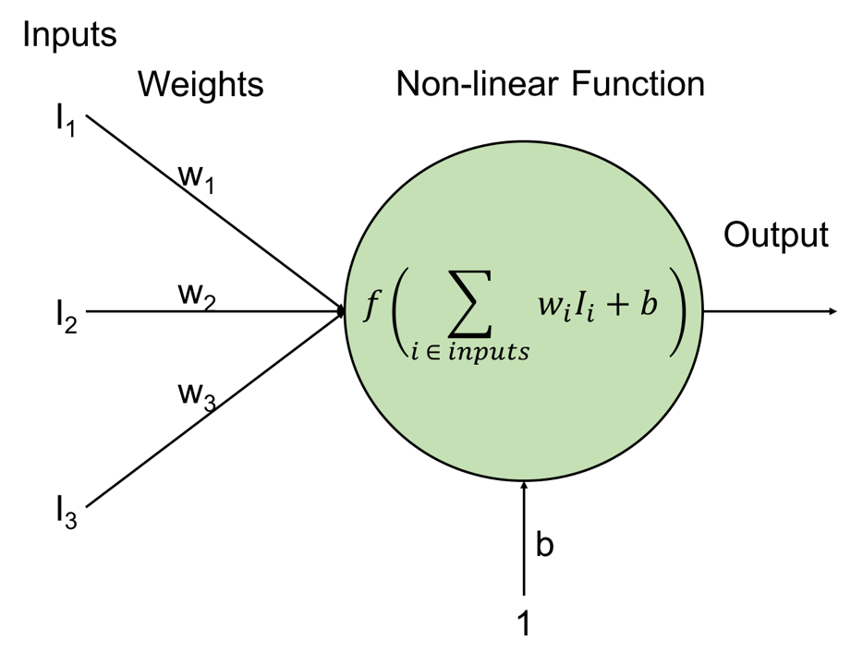
Figure 1: Within an artificial neural network, inputs (I) are multiplied by their weights (w), summed, and then evaluated by a non-linear function, which also accounts for bias ($I_{b}$). The output (θ) can be passed as input into other neurons or serve as network outputs.

Figure 2: The ResNet-18 architecture used for our experiments. The architecture (a) consists of a convolutional layer, a max pooling layer, several ResNet blocks, an average pooling layer, and a fully connected+ softmax layers at the end. The numbers after commas indicate the number of neurons in each layer and the numbers inside parenthesis indicate stride of the convolutional layers. The shortcut connection (b) of the dotted ResNet blocks (in a) increase the dimension of the signals.

References
Gelman, A., & Hill, J. (2006). Data Analysis Using Regression and Multilevel/Hierarchical Models. Leiden, UK: Cambridge University Press.
Goodfellow, I., Bengio, Y., & Courville, A. (2016). Deep Learning (1st ed.). Cambridge, Massachusetts: MIT Press.
Gurney, K. (2014). An Introduction to Neural Networks (1st ed.). London: CRC Press. Retrieved from https://www.taylorfrancis.com/books/9781482286991
He, K., Zhang, X., Ren, S., & Sun, J. (2016). Deep Residual Learning for Image Recognition. In Proceedings of the IEEE conference on computer vision and pattern recognition (pp. 770–778). IEEE. doi:10.1109/CVPR.2016.90
Mohri, M., Rostamizadeh, A., & Talwalkar, A. (2012). Foundations of Machine Learning. MIT Press.
Norouzzadeh, M. S., Nguyen, A., Kosmala, M., Swanson, A., Palmer, M. S., Packer, C., & Clune, J. (2018). Automatically identifying, counting, and describing wild animals in camera-trap images with deep learning. Proceedings of the National Academy of Sciences, 201719367. doi:10.1073/pnas.1719367115
Rumelhart, D. E., Hinton, G. E., & Williams, R. J. (1986). Learning representations by back-propagating errors. Nature, 323(6088), 533–536. doi:10.1038/323533a0
Simonyan, K., & Zisserman, A. (2014). Very deep convolutional networks for large-scale image recognition. ArXiv:1409.1556 [Cs]. Retrieved from http://arxiv.org/abs/1409.1556

